**Hardware Design**

1. **Schematic Design**

In this project, we have designed a schematic for our Flyback Converter hardware, by considering detailed simulation with LT8316 and DC2718A Demo Board Schematic, which is a 16V-600V input, 12V-3A output Flyback Converter demo board with LT8316. As a consequence of having a capable controller and tertiary winding transformer, we do not need any digital isolator (i.e. optocoupler) between two isolation boundaries. So, we have concluded our schematic with controller, transformer, connectors and some discrete components (discussed in component selection part) such as resistors, capacitors, diodes. We have not needed any extra ICs.

In component selection part, we have discussed feedback resistors, UVLO resistors and sense resistor for controller. However, there are some additional recommended components, that we placed in our schematic design. We can have a short discussion about these components:

**IntVcc Pin:** This pin is to maintain internal supply voltage that is taken from the Bias pin. In order to do that, datasheet recommends minimum 2.2uF capacitor, in schematic we have placed a 4.7uF capacitor.

**Bias Pin:** This pin takes the internal supply voltage from tertiary windings, so the datasheet recommends a bypass capacitor to ground. We have placed a 4.7uF ceramic capacitor, again.

**Smode Pin:** This pin is used for stand-by operation. In order yo avoid that we have connected it to ground.

**Vc Pin:** This pin is the Loop Compensation pin, which determines the switching frequency from the feedback voltage. Datasheet recommends an R-C network to stabilize the regulation generally with 20kohm resistor and 220nF capacitor. Normally decreasing R value and increasing C value causes transient problems and increasing R value and decreasing C value causes high frequency problems. However, when we examine the demo board discussed above, the R-C network is constructed with 10kohm resistor and 100nF capacitor. When we compare these values with the datasheet recommendation, we see that the demo board application gives better transient values, so we have used 10kohm resistor and 100nF capacitor in our hardware design.

**IREG/SS Pin:** This pin helps to regulate the output current. From this pin, 10uA current flows, and with the connected resistor, the voltage drop on the pin adjusts the current regulation. When we look datasheet, a formula is provided for this pin’s resistor, so when we calculate the needed resistor for 8.33A output current, we see that we need to connect a 50kohm resistor between this pin and ground.

**TC Pin:** This pin is used for Temperature Compensation, and from this pin to feedback pin a temperature compensation resistor is connected. Normally, there is a temperature coefficient that is found experimentally from the output diode voltage and temperature change, than the required resistance of this pin is calculated from this coefficient. However, in this project we are not able to implement that test, so we will use the demo board’s TC resistor which is 121kohm.

In addition to these recommended components by datasheet, we have used some additional components, which are input ceramic capacitors to compensate high frequency problems from input, and we have used a MOSFET gate resistor to limit the dI/dT ratio of gate current, and lastly we have used a gate pull-down resistor to prevent any failure which may occur from controller.

In figure 1, we can see the input connector and the input bypass capacitors, in figure 2 we can see the output connector, and finally in figure 3 we can see the schematic design of our Flyback Converter and controller.

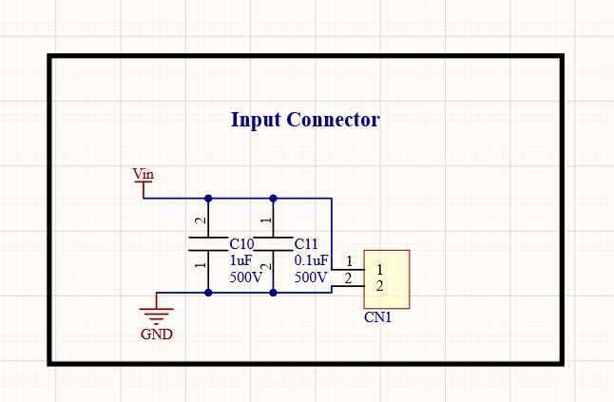

**Figure 1:** Input Connector and Input Bypass Capacitors

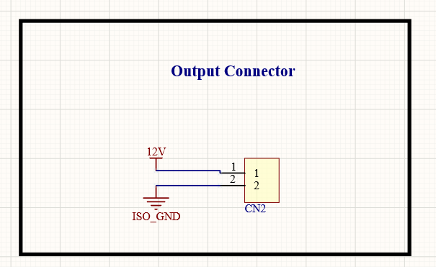

**Figure 2:** Output Connector

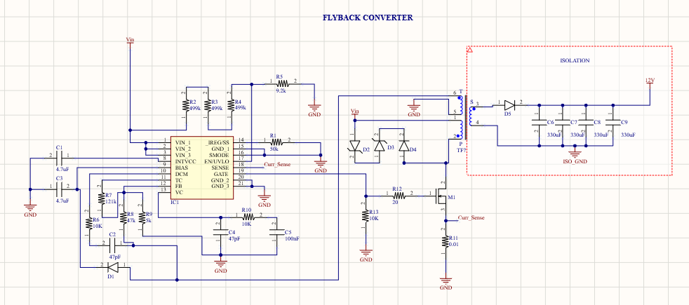

**Figure 3:** Flyback Converter and Controller